Mongo import utility to load the data set:
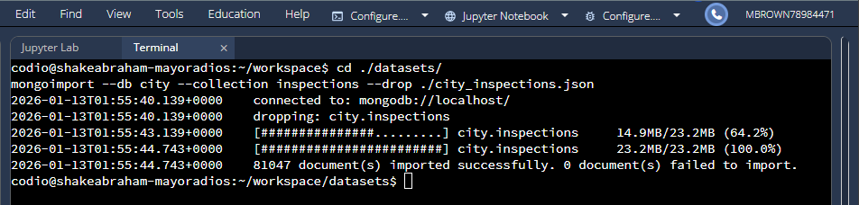

Verifying load:
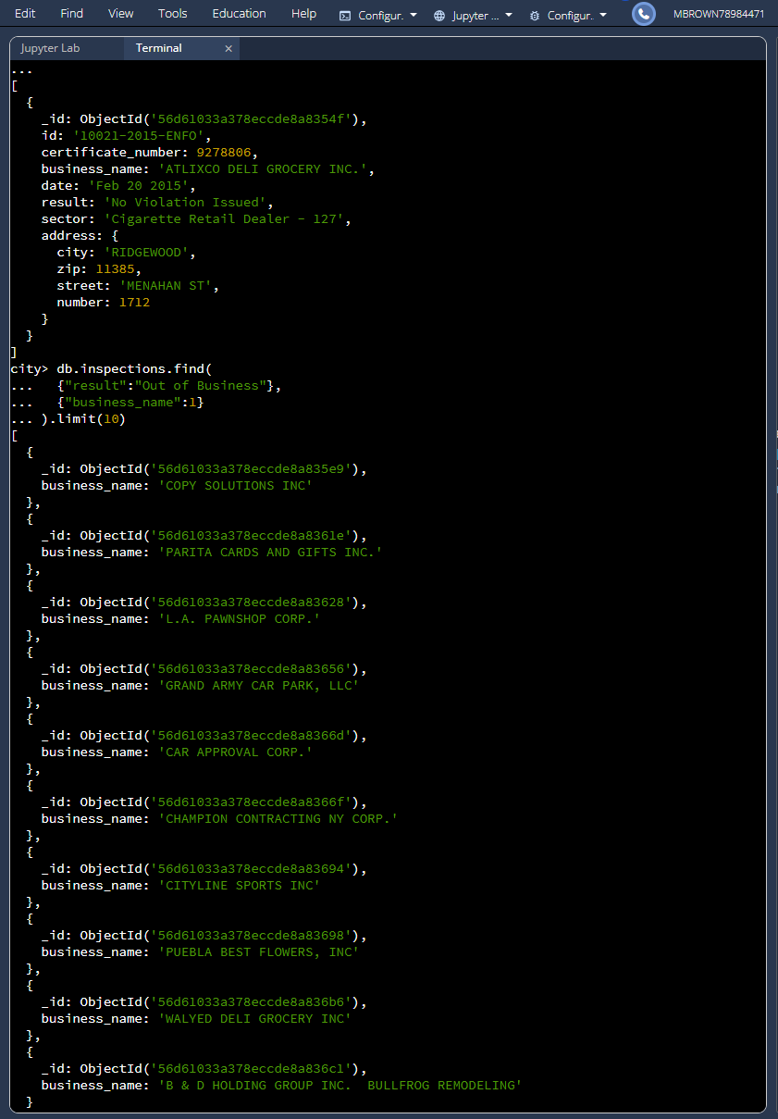

Insert a document:
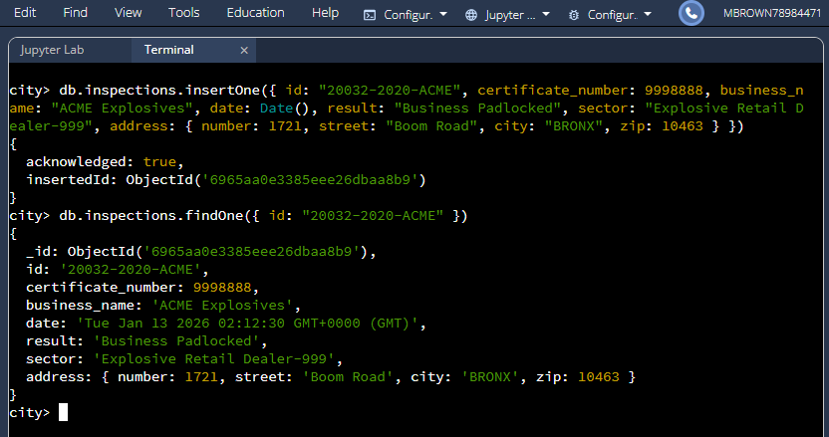

MongoDB queries:
What is the distinct list of inspection “sector” in the current inspections collection? How many are in the list?
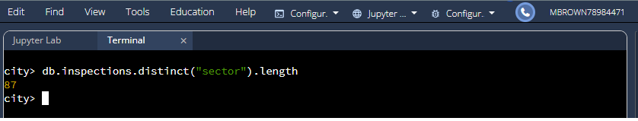
What is the difference in the date data type for the business named “AUSTIN 2012” versus your business document insertion of “Acme Explosives”?
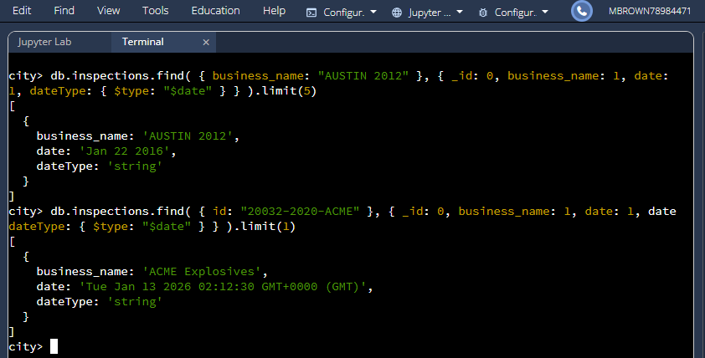
How many businesses have a “Violation Issued”?
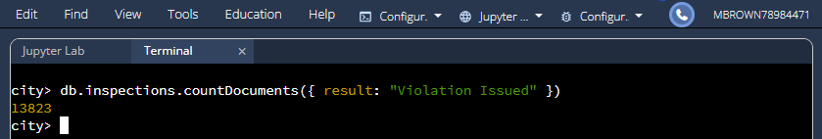

Using the appropriate command in the mongo shell, update the document with the ID “20032-2020-ACME” in the collection “inspections” in the database “city”

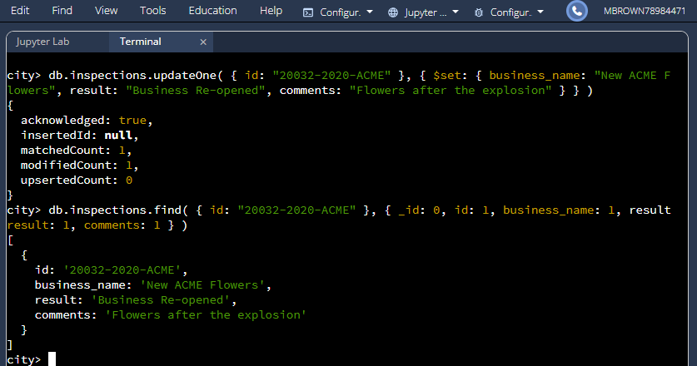

Update all the documents that contain the key-value pair "city":"ROSEDALE" in the address subdocument by changing the zip code in the address subdocument to "76114".
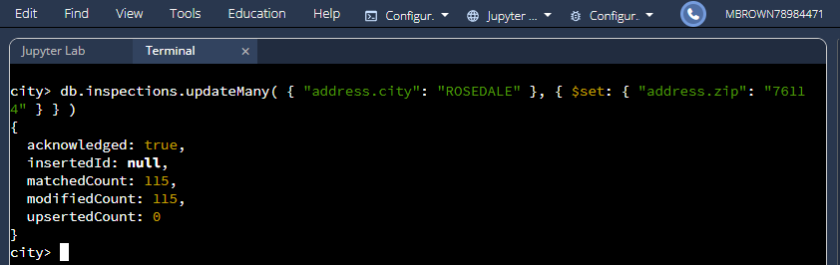
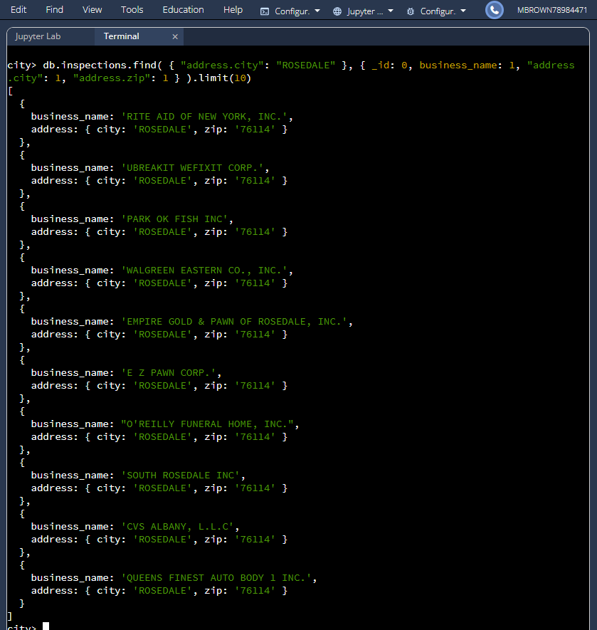

Remove the first document with the key-value pair "result":"Violation Issued".
